Name: Prof. M. T. Ingale
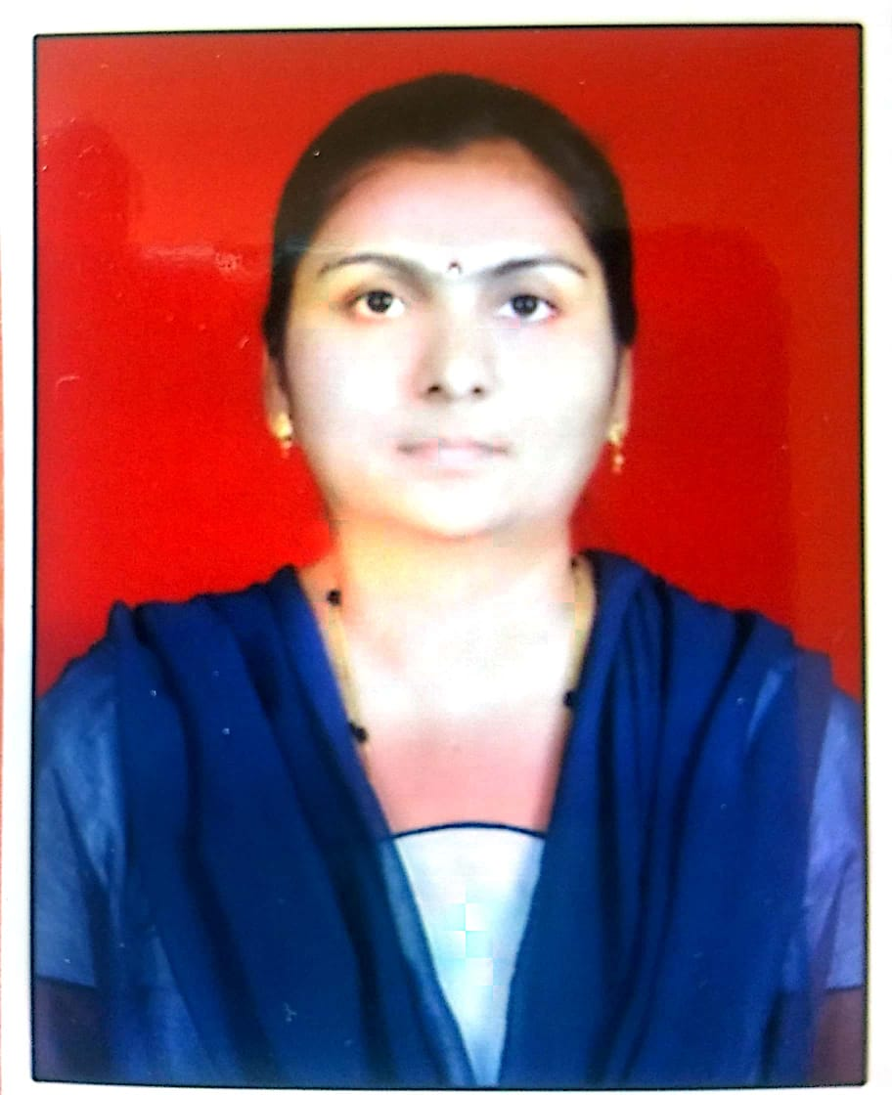
Designation: Assistant Professor
Qualification: M.Sc.(Organic Chemistry), B.Ed., Ph.D (Pur.)
Age: 40 years
Experience: 15 years
Email Id: madhuriingale@orchidengg.ac.in
Area of Interest: Organic Chemistry, Nanomaterials.
Publications:
1. International Conference: 1
2. National Conference: Nil
3. International Journal: 1
4. National Journal: Nil
Subject Taught:
1. Engg.Chemistry
2. Engg.Physics
3. Envirnmental Science
4. Energy & Envirnmental Engg.
Awards & Recognition:
Best Teacher award in the year 2017.
Achievements:
Stood Fourth in University ranks at PG level
Conferences / STTP / Workshops
Conference-2
STTP- 4
Workshops- 6
Committee Member:
1) Magazine Committee Member
2) Institute Counceling Coordinator
Professional Memberships: ---

